**Program No.06**

**Program title** To show working of pir sensor

**Aim**

Led should on when it detects human and off when it doesnot

**Hardware Required**

Arduino board

LDR sensor

**Circuit**

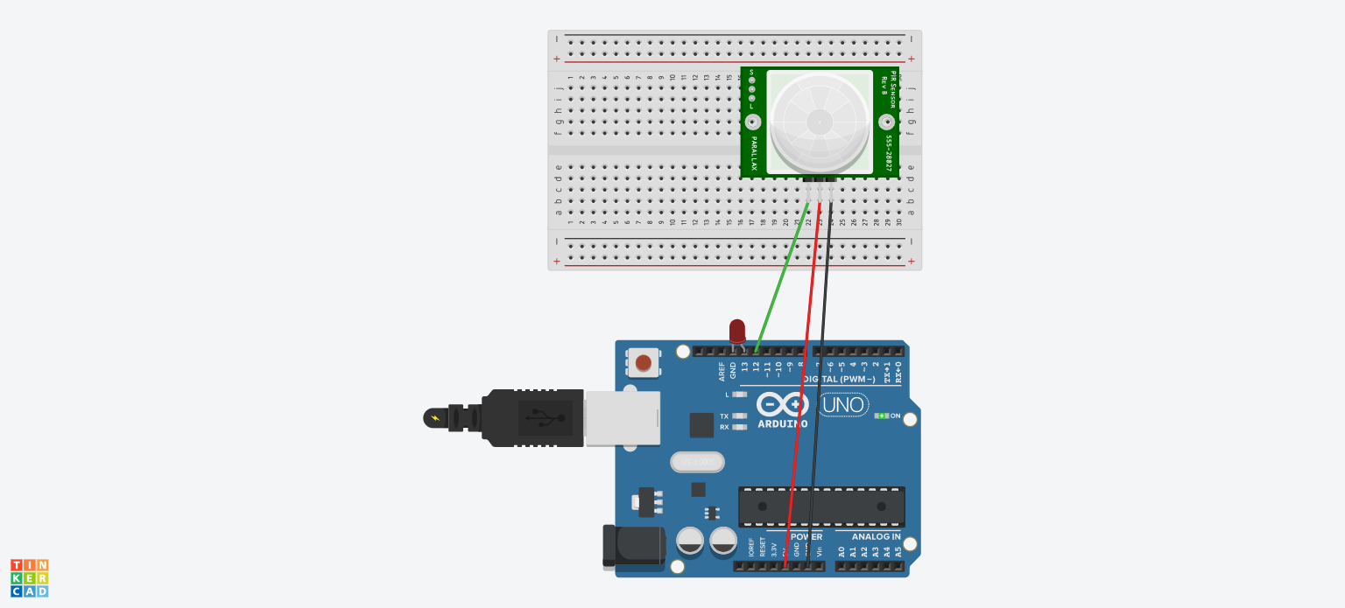

**Code**

void setup()

{

pinMode(12, INPUT);

pinMode(13,OUTPUT);

}

void loop()

{

int value=digitalRead(12);

if(value==HIGH)

digitalWrite(13,HIGH);

else

digitalWrite(13,LOW);

} **Observation**

Led is on when human is detected

And off when human is not detected